Lab 3
Supplier
SupplierID | Name | Address
S01 | ABC Company | KL
S02 | XYZ Company | PJ
S03 | HJK Company | PJ
S04 | PQR Company | JB

Primary key: SupplierID

Product
ProductID | Name | Price | Quantity
P01 | Keyboard | 80 | 60
P02 | Mouse | 30 | 70
P03 | Monitor | 200 | 80
P04 | Pendrive | 40 | 50

Primary key: ProductID

Supplies
SuppliesID | SupplierID | ProductID | Date | Quantity
001 | S01 | P01 | 1/ 1/17 | 100
002 | S01 | P02 | 2/2/2017 | 200
003 | S01 | P03 | 2 /3/2017 | 300
004 | S02 | P03 | 3/4/2017 | 400

Primary key: SuppliesID
Foreign Key: SupplierID, ProductID

- Using Ms SQL Server, create a new database Lab 3
- Write query to create the tables given above
- Write query to add each row of data into the tables
- Generate the database diagram
Execute this statement first:
Alter Authorization on Database::Lab3 To [sa];
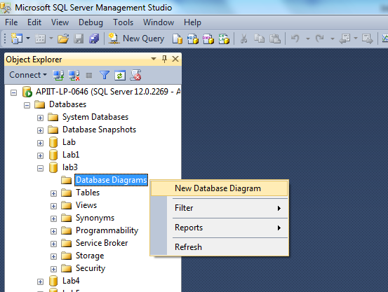

Attributes | Data Type
SupplierID | nvarchar(50)
Name | nvarchar(50)
Address | nvarchar(50)

Attributes | Data Type
ProductID | nvarchar(50)
Name | nvarchar(50)
Price | integer
Quantity | integer

Attributes | Data Type
SuppliesID | nvarchar(50)
SupplierID | nvarchar(50)
ProductID | nvarchar(50)
Date | date
Quantity | integer

Reference:
https://www.w3schools.com/sql/default.asp

